<https://github.com/mdhack0316/nodejs-openshift>

<https://github.com/mdhack0316/openshiftphp>

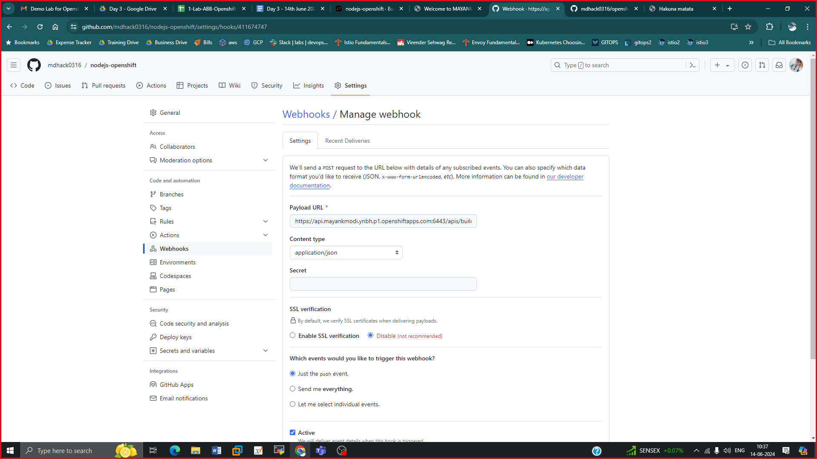

472 oc get all

473 oc new-app https://github.com/mdhack0316/openshiftphp

474 git

475 yum install git -y

476 git

477 oc new-app https://github.com/mdhack0316/openshiftphp

478 oc get all

479 oc logs -f buildconfig/openshiftphp

480 oc expose svc openshiftphp

481 oc get route

482 oc get build

484 oc get buildconfig

485 oc get pods

486 oc start-build openshiftphp

487 oc logs -f buildconfig/openshiftphp

488 oc get pods

489 oc get pods -w

490 oc logs -f buildconfig/openshiftphp

491 oc get pods

492 oc logs -f buildconfig/openshiftphp

493 oc delete all --all --force

Q>1 Clone my both github repo

Q>2 Deploy application using openshiftphp url using CLI method in Openshift

Q>3 Make sure to update the update the application in github and then manually update in openshift

Q>4 Using console deploy nodejs application and make it automatically updatable.

STORAGE

469 oc create deployment mayank --image quay.io/mayank123modi/myhttpd

470 oc expose deployment mayank --port 80

471 oc expose svc mayank

472 oc get route

473 curlmayank-mayank.apps.mayankopenshift.openshiftlabs.xyz

474 curl mayank-mayank.apps.mayankopenshift.openshiftlabs.xyz

475 oc get pods

476 vim index.html

477 oc exec -it mayank-5d8dcff76d-lfvx4 -- bash

478 oc cp index.html mayank-5d8dcff76d-lfvx4:/usr/local/apache2/htdocs

479 curl mayank-mayank.apps.mayankopenshift.openshiftlabs.xyz

480 oc delete pod mayank-5d8dcff76d-lfvx4

481 oc cp index.html mayank-5d8dcff76d-lfvx4:/usr/local/apache2/htdocs

482 curl mayank-mayank.apps.mayankopenshift.openshiftlabs.xyz

483 vim pvc.yml

484 oc get sa

485 oc get sc

486 vim pvc.yml

487 oc create -f pvc.yml

488 oc get pvc

489 oc describe pvc myclaim

490 oc get pvc

491 oc create deployment mayank --image quay.io/mayank123modi/myhttpd --dry-run -o yaml > storage.yml

492 vim storage.yml

493 oc get all

494 oc delete all --all --force

495 oc get pvc

496 oc create -f storage.yml

497 oc get pvc , pv

498 oc get pv

499 oc get pvc

500 oc get all

501 oc expose deployment mayank --port 80

502 oc expose svc mayank

503 oc get route

504 curl mayank-mayank.apps.mayankopenshift.openshiftlabs.xyz

505 oc get pods

506 oc cp index.html mayank-5d64ffb466-f98d2:/usr/local/apache2/htdocs/

507 curl mayank-mayank.apps.mayankopenshift.openshiftlabs.xyz

508 oc delete pod mayank-5d64ffb466-f98d2

509 curl mayank-mayank.apps.mayankopenshift.openshiftlabs.xyz

510 oc get sc,pv,pvc,all

511 vim storage.yml

512 history

[root@openshift ~]# cat pvc.yml

kind: PersistentVolumeClaim

apiVersion: v1

metadata:

name: myclaim

spec:

accessModes:

- ReadWriteOnce

resources:

requests:

storage: 1Gi

storageClassName: gp3-csi

[root@openshift ~]# cat storage.yml

apiVersion: apps/v1

kind: Deployment

metadata:

creationTimestamp: null

labels:

app: mayank

name: mayank

spec:

replicas: 1

selector:

matchLabels:

app: mayank

strategy: {}

template:

metadata:

creationTimestamp: null

labels:

app: mayank

spec:

volumes:

- name: mayankvol

persistentVolumeClaim:

claimName: myclaim

containers:

- image: quay.io/mayank123modi/myhttpd

name: myhttpd

volumeMounts:

- name: mayankvol

mountPath: /usr/local/apache2/htdocs/

***HEalth Checks***

[root@openshift ~]# cat jenkins.yml

apiVersion: v1

kind: Pod

metadata:

creationTimestamp: null

labels:

run: jenkins

name: jenkins

spec:

containers:

- image: jenkins/jenkins:lts

name: jenkins

[root@openshift ~]# cat testjenkins.yml

apiVersion: v1

kind: Pod

metadata:

creationTimestamp: null

labels:

run: jenkins

name: jenkins

spec:

containers:

- image: jenkins/jenkins:lts

name: jenkins

readinessProbe:

failureThreshold: 12

httpGet:

path: /login

port: 8080

initialDelaySeconds: 90

periodSeconds: 10

successThreshold: 1

timeoutSeconds: 5

livenessProbe:

failureThreshold: 12

httpGet:

path: /login

port: 8080

initialDelaySeconds: 90

periodSeconds: 10

timeoutSeconds: 5

[root@openshift ~]# cat svcjenkins.yml

apiVersion: v1

kind: Service

metadata:

creationTimestamp: null

labels:

app: jenkins

name: jenkins

spec:

ports:

- name: "8080"

port: 8080

protocol: TCP

targetPort: 8080

selector:

run: jenkins

type: ClusterIP

status:

loadBalancer: {}

483 oc get all

484 vim jenkins.yml

485 cat jenkins.yml

486 oc create service clusterip --tcp 8080 --dry-run -o yaml

487 oc create service clusterip jenkins --tcp 8080 --dry-run -o yaml

488 oc create service clusterip jenkins --tcp 8080 --dry-run -o yaml > svcjenkins.yml

489 vim jenkins.yml

490 vim svcjenkins.yml

491 oc create -f svcjenkins.yml

492 oc login -u admin

493 oc create -f svcjenkins.yml

494 oc expose svc jenkins

495 oc get route

496 oc create -f te

497 oc create -f tes

498 oc create -f jenkins.yml

499 oc get pods -o wide

500 oc get pods -o wide -w

501 vim testjenkins.yml

502 oc delete pod jenkins

503 oc create -f testjenkins.yml

504 oc get pods

505 oc get pods -w

506 watch oc get pods

507 oc describe pod jenkins

508 oc get pods

509 oc exec -it jenkins -- bah

510 h

511 oc exec -it jenkins -- bash

512 oc get pods

513 cat jenkins.yml

514 cat testjenkins.yml

515 cat svcjenkins.yml

**Q.1 Deploy jenkins normally with above yamland verify that before starting the service my req sent to pod**

**Q>2 Deploy jenkins with health checks and check same thing**

**For authentication**

**553 htpasswd**

**554 htpasswd -cBb creds mayank redhat**

**555 cat creds**

**556 htpasswd -Bb creds training redhat**

**557 cat creds**

**558 oc login -u mayank**

**559 cat creds**

**560 cd op**

**561 ls**

**562 cd openshift/**

**563 ls**

**564 cat creds**

**565 htpasswd -Bb creds mayank redhat**

**566 htpasswd -Bb creds trainingredhat**

**567 htpasswd -Bb creds training redhat**

**568 cat creds**

**569 oc create secret generic mayank --from-file htpasswd=creds -n openshift-config**

**570 oc create secret generic modi --from-file htpasswd=creds -n openshift-config**

**571 oc get secret -n openshift-con**

**572 oc get secret -n openshift-config**

**573 oc get all -n openshift-authentication**

**574 vim oauth.yaml**

**575 oc apply -f oauth.yaml**

**576 oc get pods -n openshift-authentication**

**577 watch oc get pods -n openshift-authentication**

**578 oc login -u mayank -p redhart**

**579 oc login -u mayank -p redhar**

**580 oc login -u mayank -p redhat**

**581 oc login -u admin**

**582 #oc adm policy add-role-to-user view mayank -n mayank**

**583 oc project**

**584 oc project mayank**

**585 oc adm policy add-role-to-user view mayank -n mayank**

**586 oc get all**

**587 oc login -u mayank -p redhat**

**588 oc get all**

**589 oc run pod --image quay.io/mayank123modi/myhttpd**

**590 oc login -u admin**

**591 oc adm policy add-role-to-user edit mayank -n mayank**

**592 oc login -u mayank -p redhat**

**593 oc run pod --image quay.io/mayank123modi/myhttpd**

**594 oc delete pod pod**

**595 oc delete project mayank**

**596 oc get role**

**597 oc login -u admin**

**598 oc get role**

**599 oc get role --all-namespaces**

**600 oc get clusterrole**

**601 oc describe clusterrole cluster-admin**

**602 oc describe clusterrole view**

**603 oc describe clusterrole edit**

**604 oc login -u admin**

**Create afile**

**htpasswd -Bb creds mayank redhat**

**Then create secret**

**oc create secret generic anyname --from-file htpasswd=creds -n openshift-config**

**Use oauth.yml file**

**apiVersion: config.openshift.io/v1**

**kind: OAuth**

**metadata:**

**name: cluster**

**spec:**

**identityProviders:**

**- name: my_htpasswd_provider**

**mappingMethod: claim**

**type: HTPasswd**

**htpasswd:**

**fileData:**

**name: amyname**

**oc apply -f oauth.yaml**

***FOR authorization***

**582 #oc adm policy add-role-to-user view mayank -n mayank**

**583 oc project**

**584 oc project mayank**

**585 oc adm policy add-role-to-user view mayank -n mayank**

**586 oc get all**

**587 oc login -u mayank -p redhat**

**588 oc get all**

**589 oc run pod --image quay.io/mayank123modi/myhttpd**

**590 oc login -u admin**

**591 oc adm policy add-role-to-user edit mayank -n mayank**

**592 oc login -u mayank -p redhat**

**593 oc run pod --image quay.io/mayank123modi/myhttpd**

**594 oc delete pod pod**

**595 oc delete project mayank**

**596 oc get role**

**597 oc login -u admin**

**598 oc get role**

**599 oc get role --all-namespaces**

**600 oc get clusterrole**

**601 oc describe clusterrole cluster-admin**

**602 oc describe clusterrole view**

**603 oc describe clusterrole edit**

**604 oc login -u admin**

**admin:$2y$05$bqksEWqG3cJeSb7soHbDeef9ub6y1dZA/m9jmEfUPttuv22RVZku2**

**user1:$2y$05$0BzShrhRJ9nM1LL0T.yRIOB4ag7C.PzwLut9SJBoGDk1S0QVQXESe**

**user2:$2y$05$I5V3nC0cKswG77PTr54x1OGB4yE4b7wdlX5Q.Ehw9BJFafWZczqYS**

**user3:$2y$05$MCGtkJRzFTqSVLJsr7f4x.y0Ncltbb4tw3DhPG4iIC/02pgEV9JRC**

**user4:$2y$05$wNOqq6PfCXDCHwjMOyBNNeKgq0Ii9DmIfQjnNP5ThWlTtpW/tOTSG**

**user5:$2y$05$Uio7ZV4IIuemJe5FY1qXfe8D00Z5jkx9KRvjqvVFrVeX.KwCQnj4G**

**user6:$2y$05$DU45tzMUuhUqXwWofLh.sOpo2SLwR.kv3TDHJVBTOgSRrwJNxgZXa**

**user7:$2y$05$vNGXOxEYDErHYEgMxWgqWujYLgQiI.5ZJFE9wF9OWzXNy/qM2RyYS**

**user8:$2y$05$ctU655PFgGRlJorwjAj5A.MLHi0Cfw6eU0s9gWPOfFtqA6YTJS0hm**

**user9:$2y$05$52z4bZPKUh.VPXPV0kxtDOxD.Lj6XH2Ht3zRozulxitpVFzobOVxG**

**user10:$2y$05$KV8/.HWyyUzN2gI6tCdM0u6xcndZVY2Ep1aPX9HZG5kd9rH4l9owS**

**user11:$2y$05$BPK7CoxnFllvTo/FhIQ/Muo1L8W0QxIXG/nHiOGlJsw5IW5xMl5/6**

**user12:$2y$05$2JIji5vJHwEVbwjAvXrKg.MyoXkaHP3j.d/KOe6.R82qxtx10kj4u**

**user13:$2y$05$24AKf95l4hZd1MBHqCj.xuGDgfw6utHfODe4dMbH4Q2uWNcqAJ2DS**

**user14:$2y$05$Irq6oXq58BEm5whX8o6Et.tH8WZJxdICyuHOxdnYEFnUdvWqP7tVW**

**user15:$2y$05$tMFyVP5XbOjOHk6UHwXBZ.jhfwRh8oYvoXFoP5Qx3RnrjMcOYdMxq**

**user16:$2y$05$KW5gdTjHCcFS2to13TRoWeNPV5Q7.9mEscf4vPIHjSVR3I9RXzvyC**

**user17:$2y$05$PxRyyvjJ6TOfq9WaMJALsuactvbhWImNn5vno3xwCk.YTwGlZM7ze**

**user18:$2y$05$S4x8.k.tniVptnAnYpJ1PepVPxNpbpJHMdisnrxSmSYHKBf6Uw7lO**

**user19:$2y$05$425yrcbt4PFhiDC/dd5.k.dP1Vjtr9VE0gPh7OXTG5w5d8.num25G**

**user20:$2y$05$KKYHD7yaTKPt8mm2jGk1FuPW3k8tRJI/DEpnPPlPXdOz634TmiULO**

**mayank:$2y$05$2ApLJIv0/UOxTmSIolHOlOEsIqa0uKnfNi0fxiZHIBnTD/Duf8uHm**

**training:$2y$05$ZsS1MD875tHyHF/n5df4X.u7y4lEABlo1B9B5ZpTBX0fR5Pmvb7a.**